**PLAN**

Homepage

Navigation Bar

Logo

Layout

Search

Side Menu

Courses

About

Profile

Login/Logout

Memes

About

Contact

Send-Button

Courses

Login/Logout

Shopping cart

References and others

Background: <https://www.dreamstime.com/stock-illustration-hand-drawn-mandala-seamless-pattern-light-blue-l-tones-all-objects-conveniently-grouped-easily-editable-image49684128>

media break points

Ideas

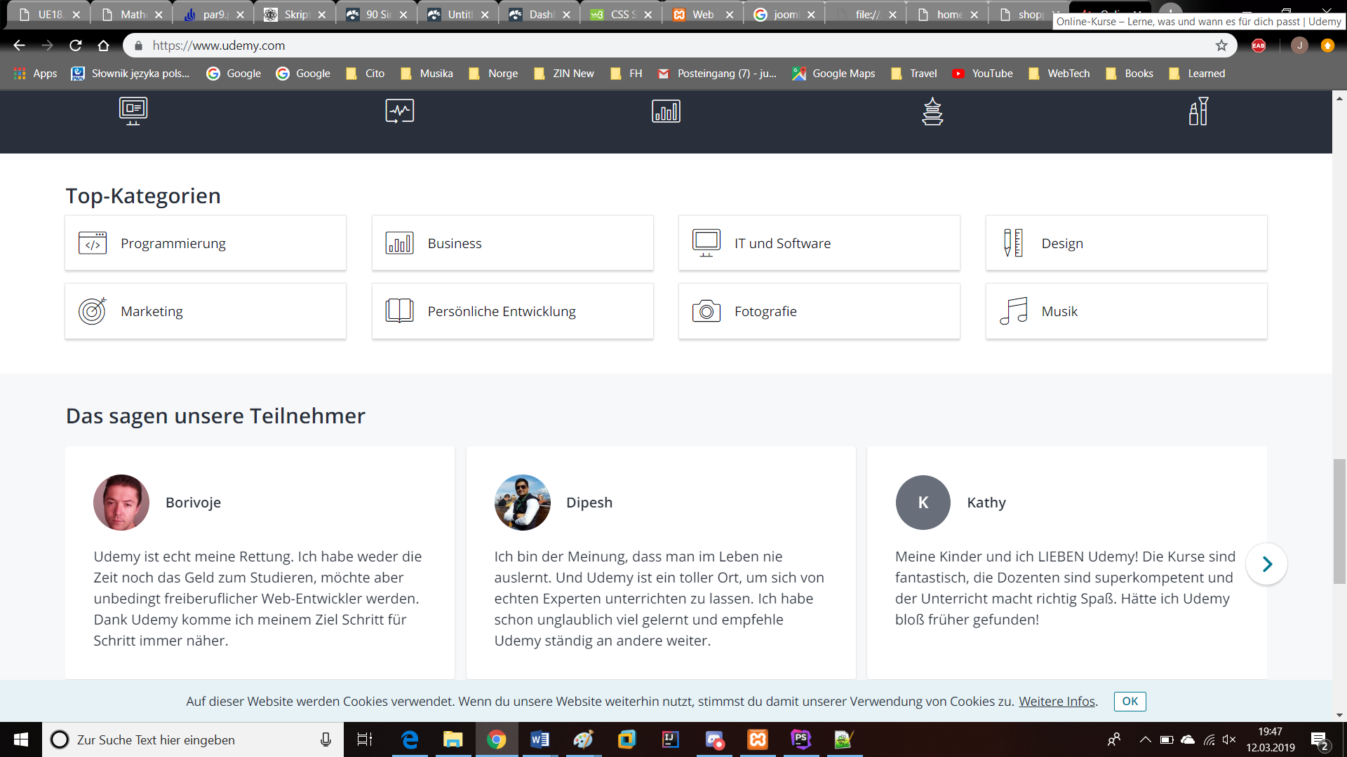



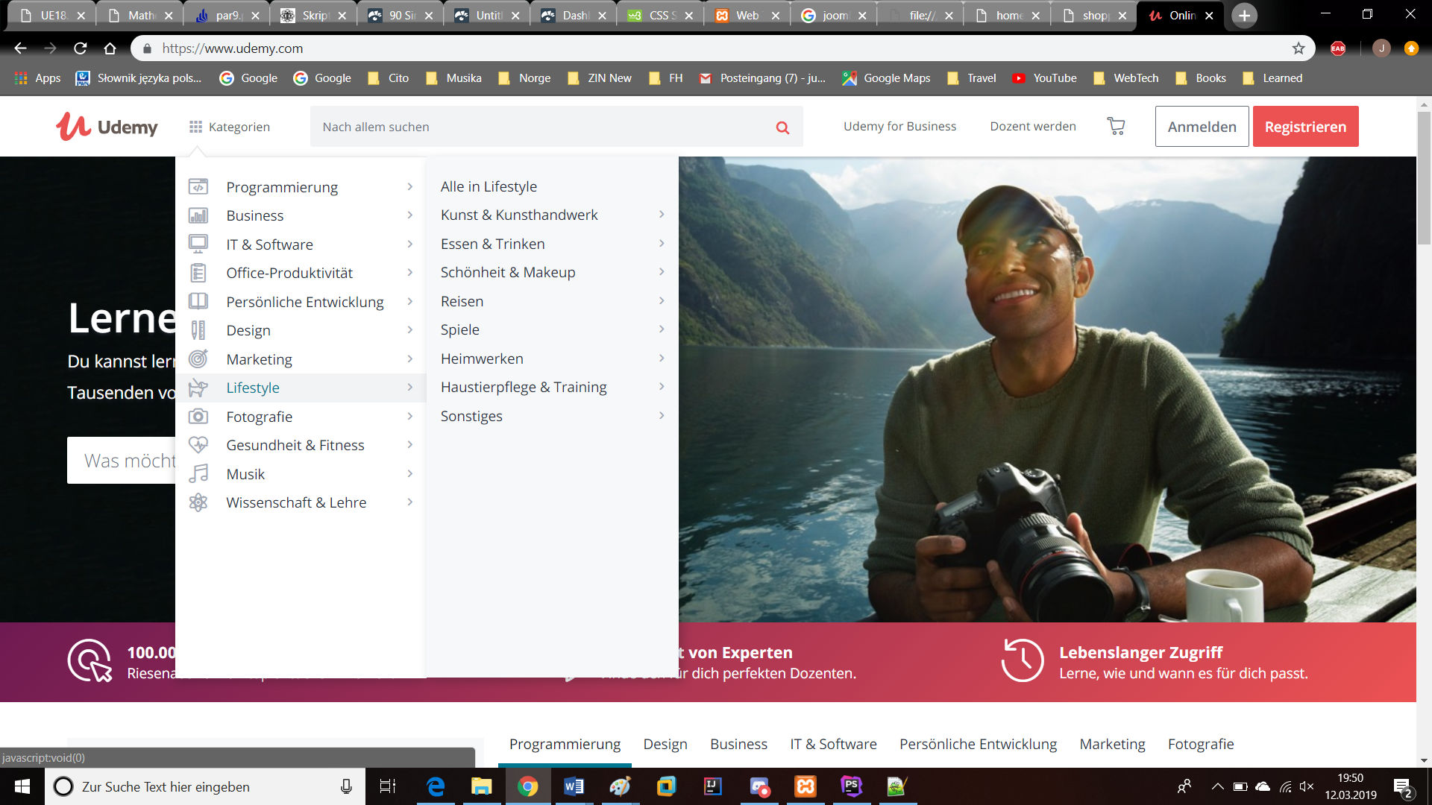

**DONATE BUTTON**

